Conference Title
- subtitle -
XX. Moving Anthropology Student Network Conference
Dates, Location

Application  form for participants | 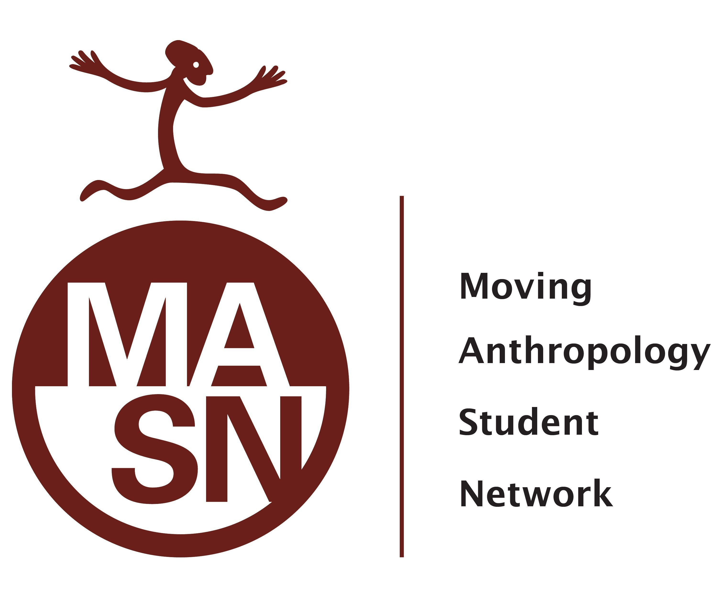

Person #1:
Name:
Cell No.: | Email:

City: | State:

University / Department/ Institution:

Travelling:
I intend to travel directly to LOCATION
I intend to travel to LOCATION and take the organized bus to the conference venue from there. Please pay attention to the bus departure times! They will be announced on the conference homepage.

Accommodation:
Notes....
Option 1
Option 2...

Please return this application form to E-MAIL ADDRESS until the DATE.
We are looking forward meeting you!
All the best!
MASN conference team

